* + **TASK 1**  
    STEP 1: Install php in the computer. Version must be greater than 8.0.  
    STEP 2: Download composer from <https://getcomposer.org/> and install it in the C drive.  
    STEP 3: Go to command prompt and check php version is greater than 8.0 and also check composer is install our PC or not.  
     STEP 4 : Go to vs code editor open the terminal and type   
    composer create-project laravel/laravel project-2
  + Here project-2 is the folder where we install our Laravel.  
     After install Laravel properly, again go to the terminal and type -  
    cd project-2  
     and give this command- php artisan serve.  
      
    then visited the URL http://localhost:8000 in my web browser, and saw the default Laravel welcome page. I took a screenshot of the welcome page as proof that Laravel was installed and working correctly.  
      
    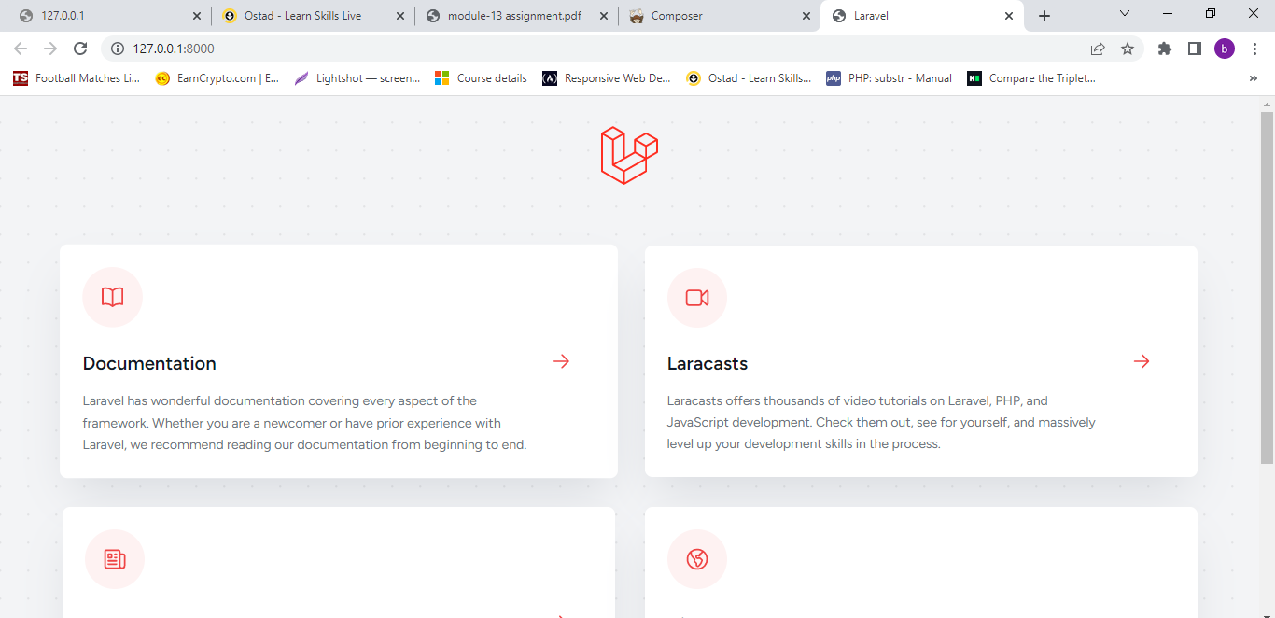  
      
      
    **TASK 2  
      
    Part 2:**   
    Laravel Folder Structure: Here is a brief description of each of the folders in a Laravel project:   
    **• app:** contains the core code of the application, including controllers, models, views, and other supporting files.  
     **• bootstrap:** contains the files needed to bootstrap the framework and configure autoloading.   
    **• config:** contains configuration files for the application, such as database connection details and environment variables.   
    **• database:** contains database-related files, including migrations and seeders.   
    **• public:** contains the front-facing assets of the application, such as CSS, JavaScript, and images.  
     **• resources:** contains the uncompiled resources, such as blade templates and JavaScript files, that will be compiled by Laravel's asset compilation system.  
     **• routes:** contains the route definitions for the application.   
    **• storage:** contains files that need to be stored for the application, such as logs, cache files, and user-generated content.   
    **• tests:** contains the automated tests for the application.  
     **• vendor:** contains the application's dependencies installed via Composer.  
      
      
    For display “Hello World!” message go to routs folder and then web.php file and open it. In web.php file type this code-  
      
    Route::get('/project13', function () { return 'Hello, World!';}); **then browse 127.0.0.1:8000/project13  
    the screenshot is below -  
      
    